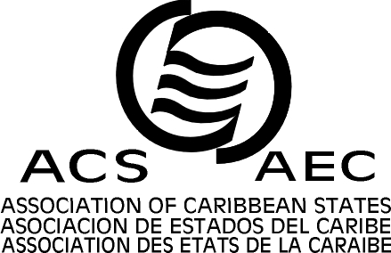


ASSOCIATION OF CARIBBEAN STATES (ACS)

XX MEETING OF THE SPECIAL COMMITTEE OF TRANSPORT
Port of Spain, Republic of Trinidad and Tobago, June 30TH and July 1st, 2011

REGISTRATION FORM

To be sent to:
e-mail: Sandra Fonseca: sfonseca@acs-aec.org
or
Marina Edwards: medwards@acs-aec.org
Fax: 1 (868) 622 1653

NAME: | ________________________________________________
TITLE: (CIRCLE ONE) | MR MRS MS DR OTHER _______________
DESIGNATION: | _______________________________________________
INSTITUTION: | _______________________________________________
ADDRESS: | _______________________________________________
CITY: | _______________________________________________
COUNTRY: | _______________________________________________
TEL: | _______________________________________________
FAX: | _______________________________________________
E-MAIL: | _______________________________________________
NATIONALITY : | _______________________________________________
PASSPORT NO:  (IF VISA IS REQUIRED) | ORDINARY ( ) DIPLOMATIC ( ) OTHER ( )  _______________________________________________
ISSUE DATE: ___________________ |  |  | EXPIRY DATE: ____________________
ARRIVAL DATE: ___________ |  | FLIGHT NO: __________ |  | TIME: ____________
DEPARTURE DATE: _________ |  | FLIGHT NO: __________ |  | TIME: ____________

